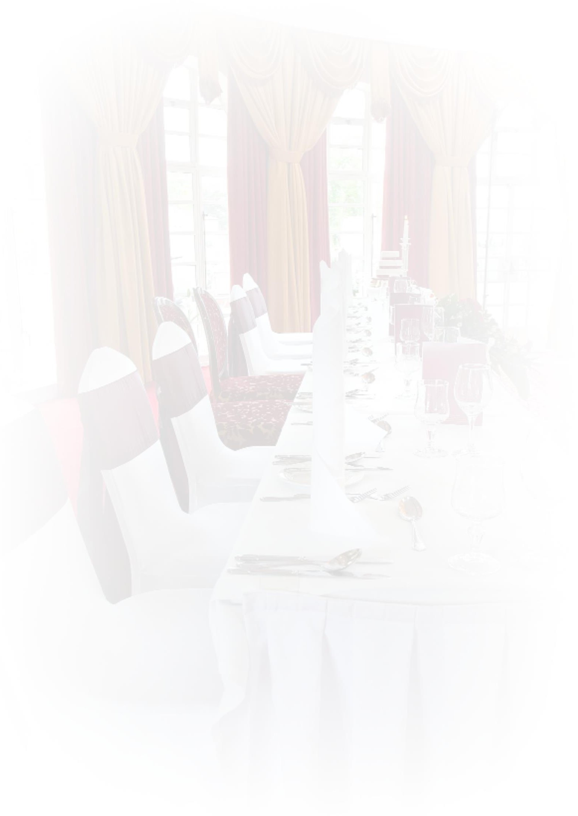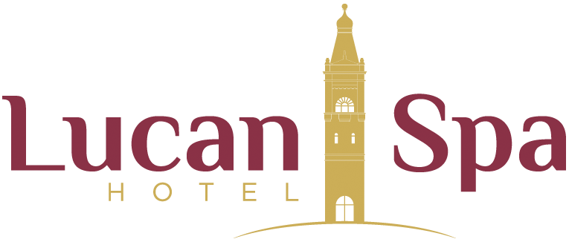

Private Banqueting Sample Menu

Cream of Fresh Vegetable Soup served with a Crispy Bread Roll
*****

Roast Breast of Turkey with Sage & Onion Stuffing & Honey Baked Ham Served with a Roasted Potato
Or

Baked Darne of Fresh Salmon served with Stir Fried Greens, Chive & Lemon Beurre Blanc
All Served With Fresh Seasonal Vegetables & Creamed Mash Potatoes.
Vegetarian and Coeliac options also available

*****
Strawberry Cheesecake served with Fresh Cream

*****
Freshly Brewed Tea or Coffee

The Lucan Spa Hotel
Junction 4A, N4 Westbound, Lucan, Co. Dublin. Tel: 01 628 0494.
Email: reservations@lucanspahotel.ie.

